# CS 255 System Design Document Template

## UML Diagrams

### UML Use Case Diagram

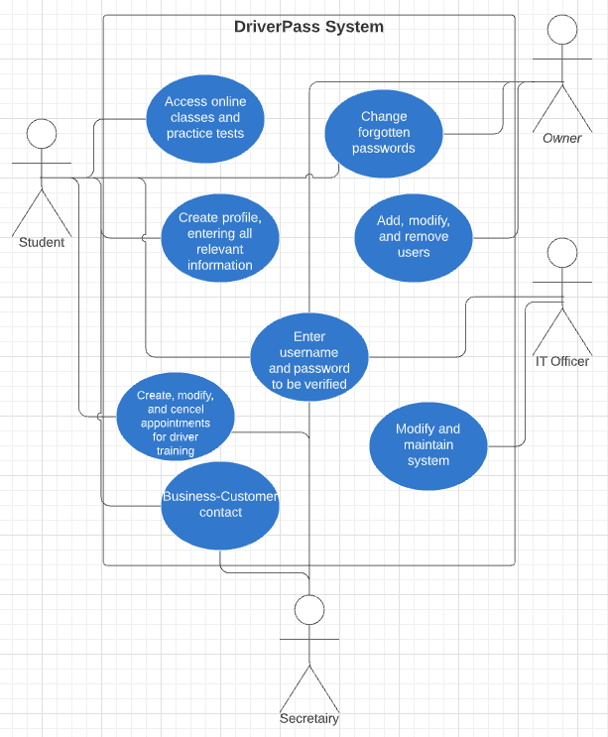

### UML Activity Diagrams

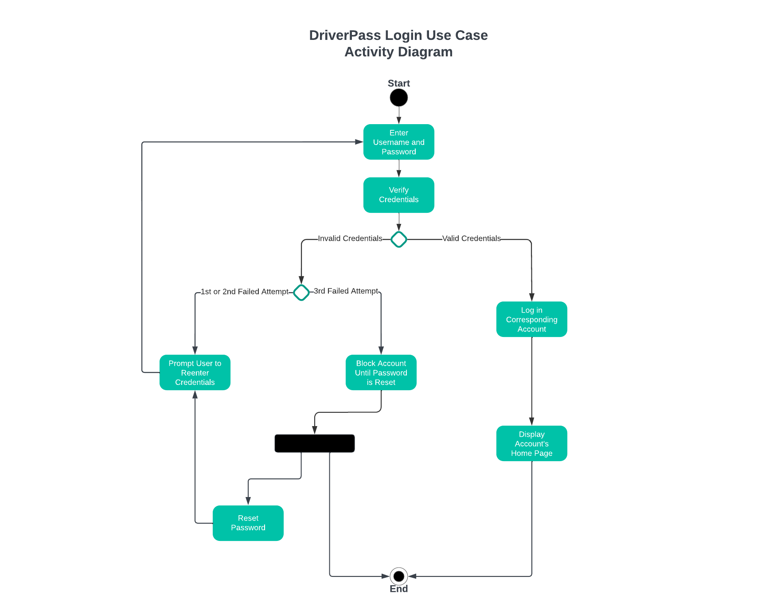

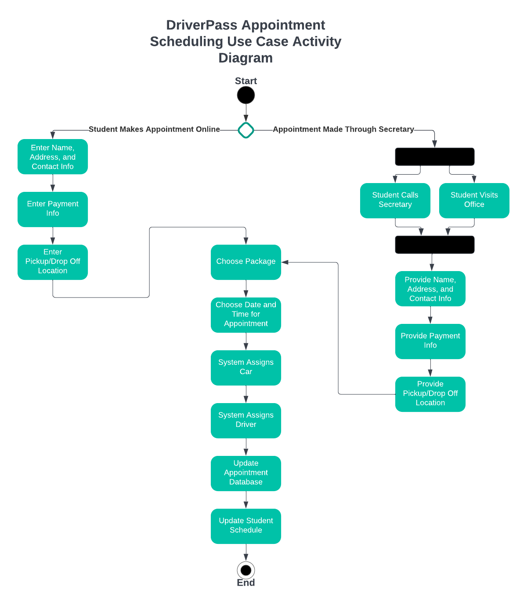

### UML Sequence Diagram

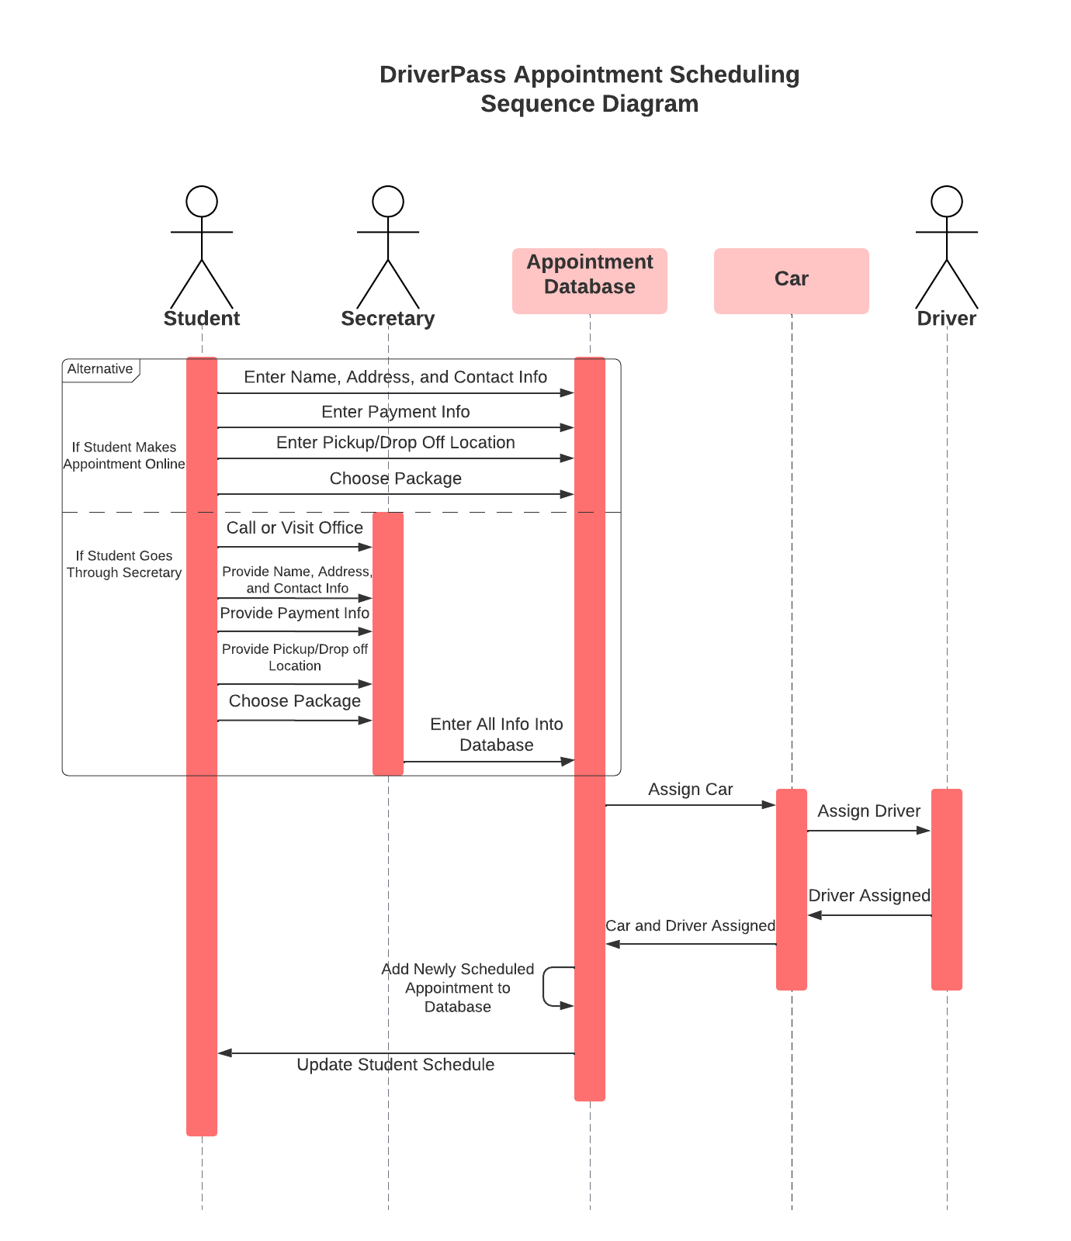

### UML Class Diagram

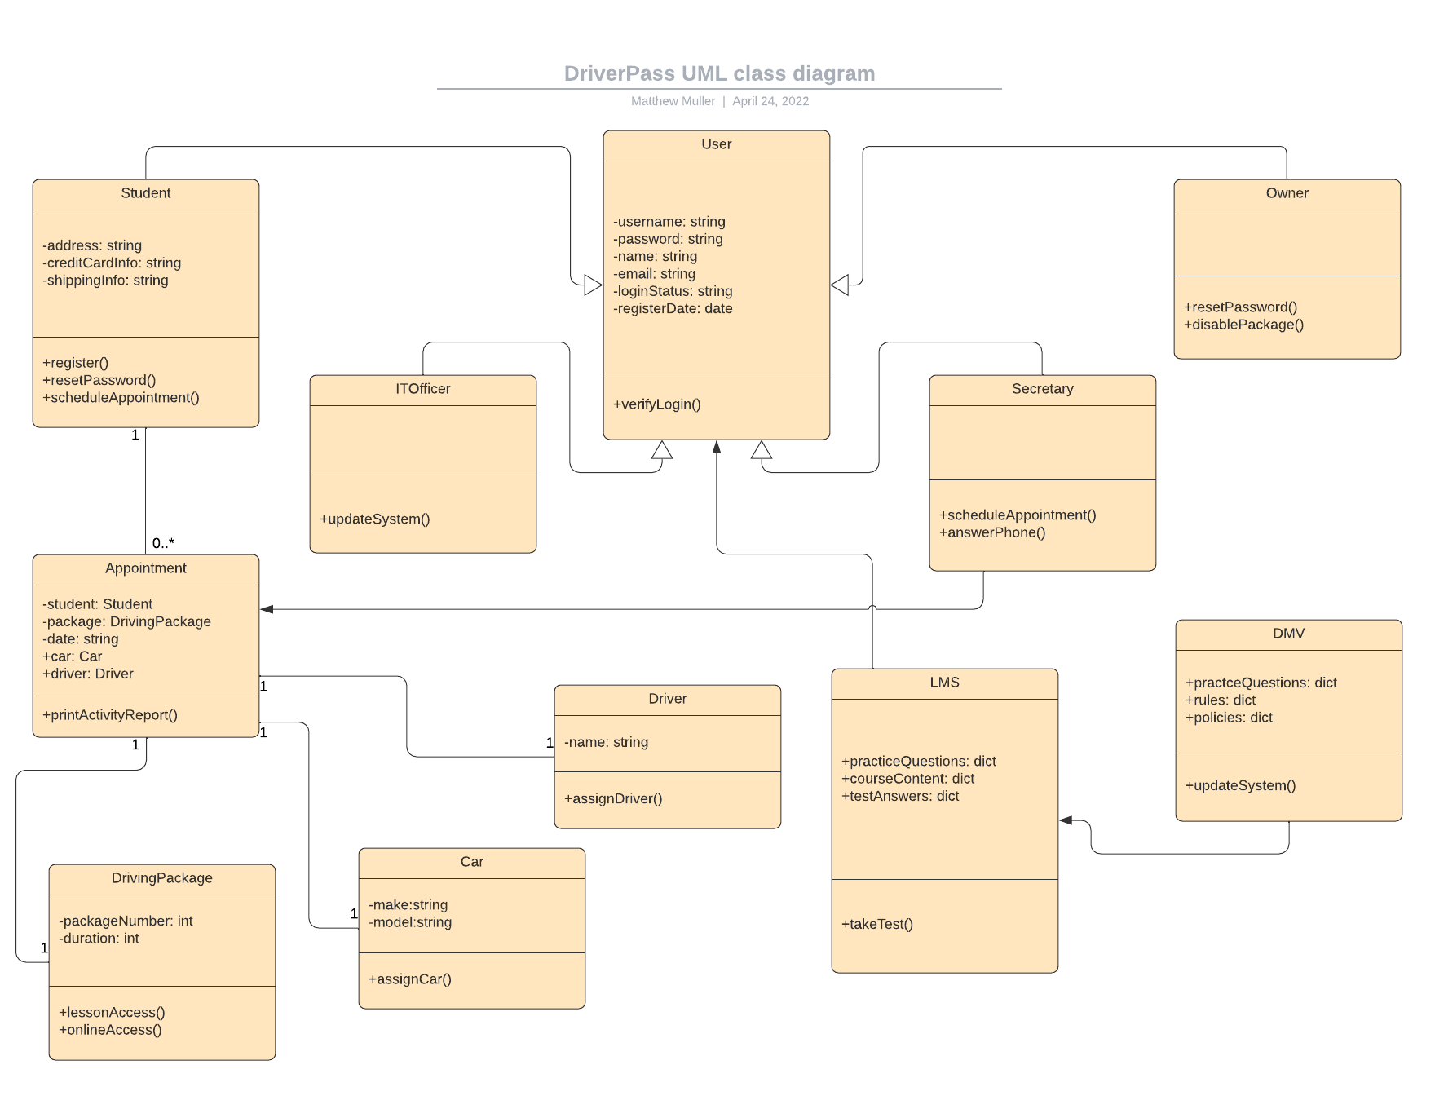

## Technical Requirements

The DriverPass system requires that it be launched as a web-based application hosted on a cloud-based server. This cloud server will house the databases required for user information, appointment scheduling, cars and drivers, and any other databases that are necessary as the system is built and updated. Another technical requirement of the system will be to access a third-party payment software such as PayPal in order for the system to process payments for the services that it provides. The system will be developed in the Java language so an IDE that allows for effective collaboration between developers using Java is another requirement for development. Finally, infrastructure that allows the DriverPass system to automatically receive updates from the various local DMVs will be a necessity.